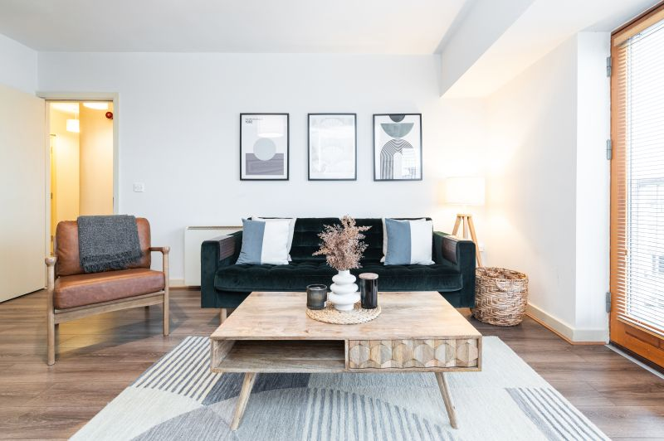

No. 26 Key West, Custom House Quay
Exceptional 2 Bed Apt, Fully Furnished – Turn-Key Condition

AMV: €239,000
PRSA Registration No.: 002141



