FOR SALE

AMV: €269,000 File No. d644.CWM
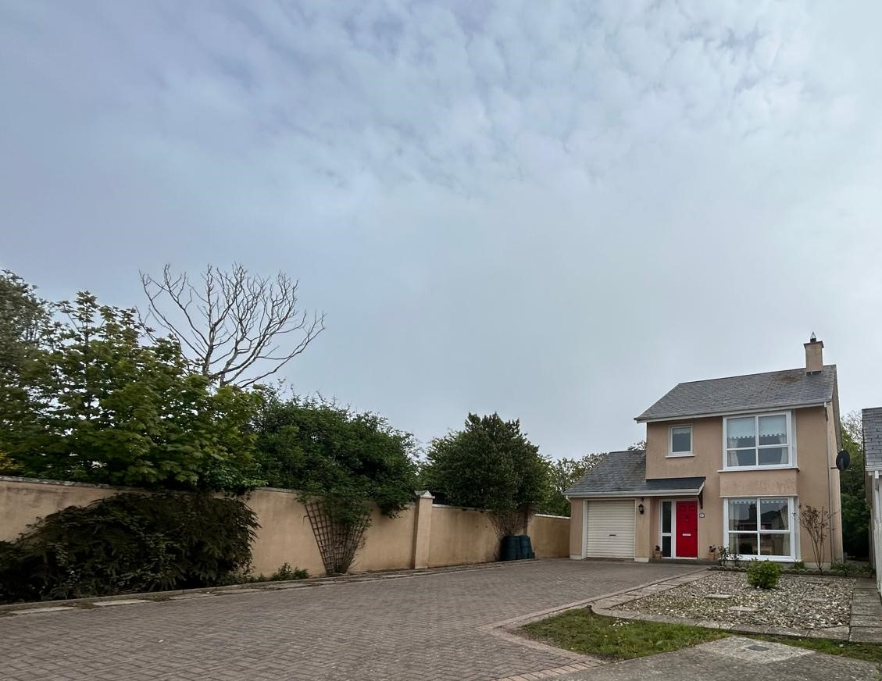



No.1 La Rochelle,
Rosslare Harbour, Wexford

- Prime location in Rosslare Harbour with easy access to Rosslare Europort and surrounding amenities including the cliff sidewalks.
- Spacious two-storey detached three-bedroom residence with integral garage offering further scope to develop.
- Well-maintained front driveway and landscaped rear garden with elevated patio.
- Light-filled living spaces including a sunroom and modern kitchen/dining area.
- Master bedroom with ensuite, two additional bedrooms, and family bathroom upstairs.

- To arrange a suitable viewing time, contact the sole selling agents
only, Kehoe & Assoc. at 053 9144393


No. 1 La Rochelle, Rosslare Harbour, Co. Wexford

Welcome to No.1 La Rochelle, Rosslare Harbour - a stunning seaside property in Wexford, Ireland. This charming home, nestled in a mature development just steps away from Rosslare Europort, offers the perfect blend of convenience and tranquillity.

Boasting a spacious two-storey layout, this three-bedroom residence is the epitome of coastal living. The property features a large driveway, a beautifully landscaped front garden, and a private south easterly aspect rear garden complete with raised beds and an elevated patio - perfect for enjoying the sea breeze and sunshine.

Inside, you'll find an inviting entrance hall, a cozy living room, a modern kitchen/dining room, a sunroom, a convenient utility room, and a guest bathroom. Upstairs, the master bedroom comes complete with an ensuite, while two additional bedrooms and a family bathroom offer plenty of space for guests or family members.

Don't miss your chance to own a piece of paradise in Rosslare Harbour. With its prime location, picturesque surroundings, and thoughtfully designed interiors, No.1 La Rochelle is the perfect place to call home. Schedule a viewing today and make your seaside dreams a reality.

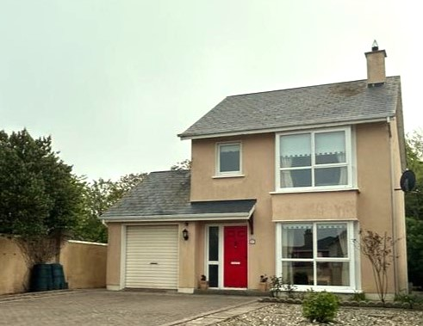

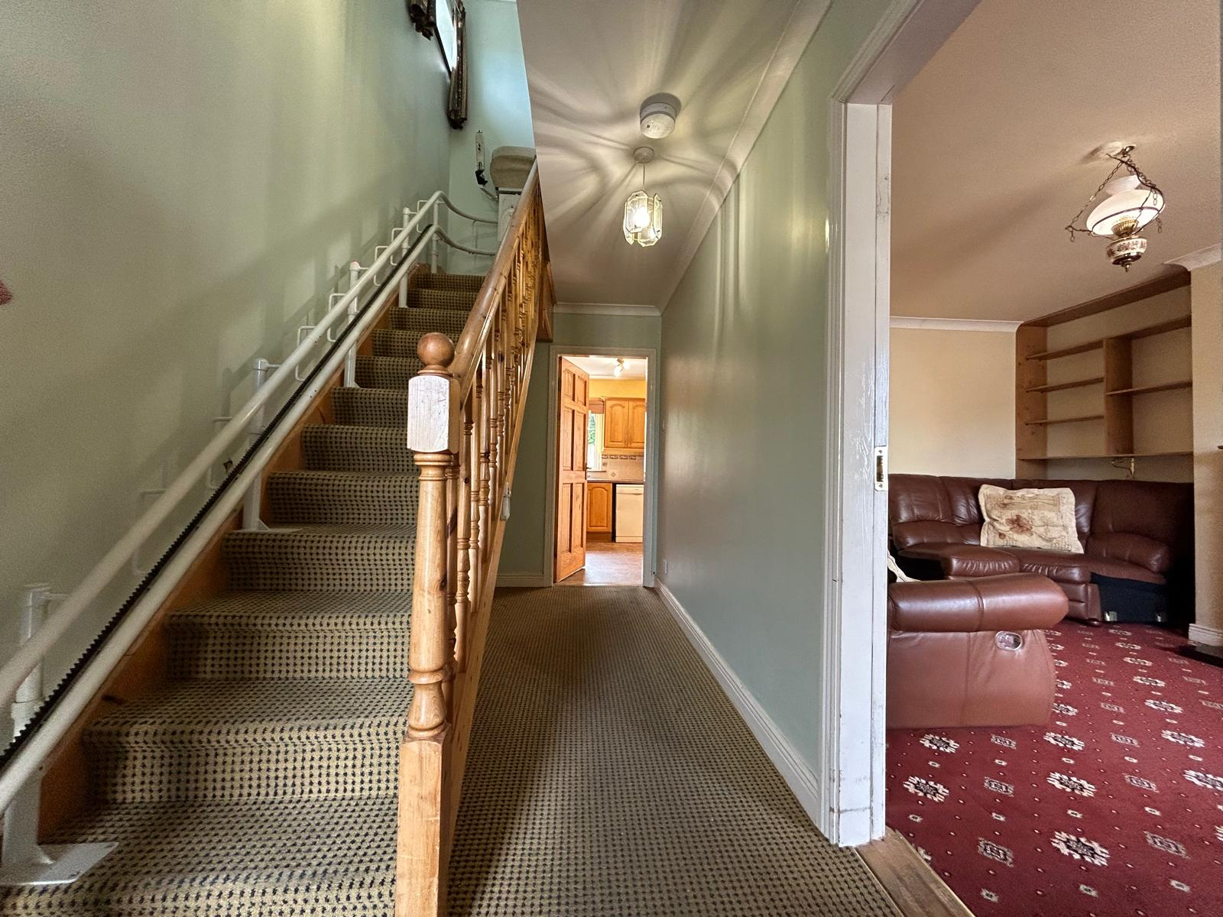
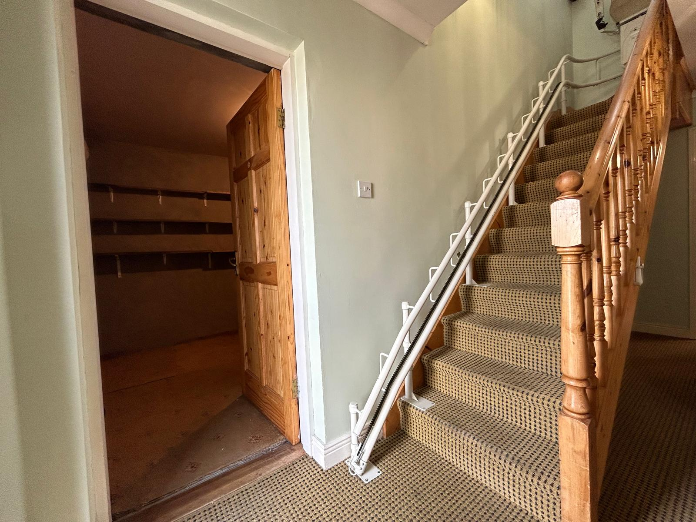

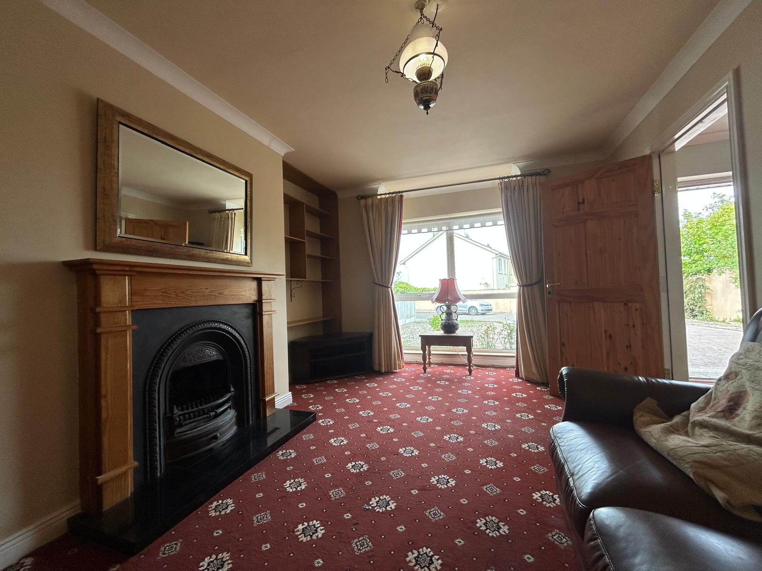
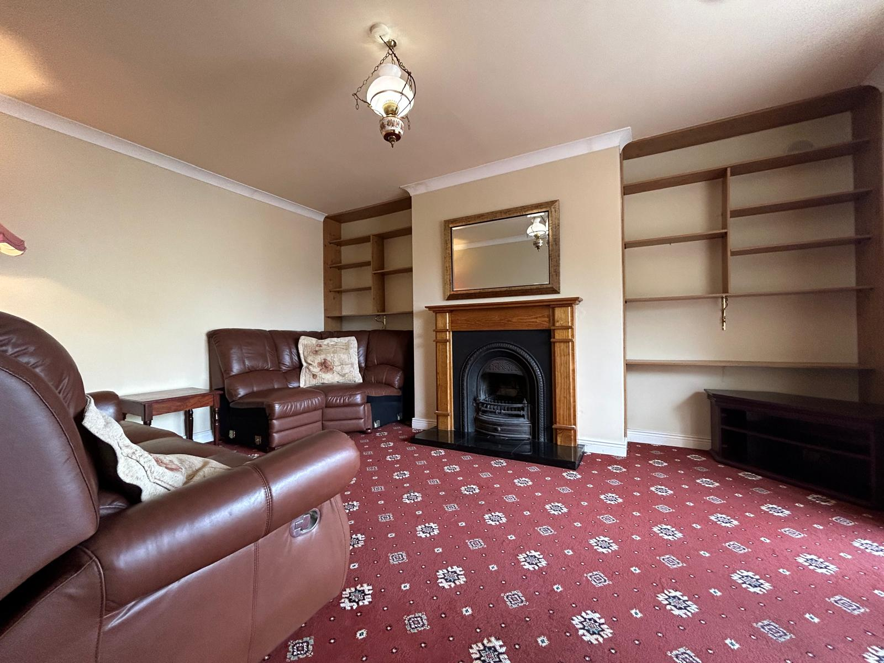

Accommodation

Ground Floor
Entrance Hall | 4.79m x 1.90m | Carpeted flooring, telephone, and broadband points. Door leading to sitting room.
Sitting Room | 4.78m x 3.55m | Carpeted flooring, open fireplace with cast iron insert and timber surround, granite stone tile hearth, display cabinets left and right of the chimney breast and a bay window overlooking the front driveway.
Kitchen / Dining Room | 5.59m x 3.27m | Lino flooring, fully fitted kitchen, floor and eye level cabinets, ample worktop space, double drainer stainless steel sink and tile splash back. Window overlooking rear garden. Town & Country gas oven with 4 ring gas hob extractor fan overhead, Bosch dishwasher and free standing Siemens fridge freezer. Double doors leading to the sunroom.
Sunroom | 4.43m x 3.04m | Timber laminate flooring.
Utility Room / Back Porch | 2.12m x 1.60m | Lino flooring, Hotpoint washing machine under counter, under counter firebird internal boiler, worktop space, open shelves and built-in presses overhead. Door leading to guest bathroom. Door leading to rear garden.
Guest Bathroom | 1.97m x 0.82m | Lino flooring, part-tile wall surround, w.h.b. and mirror overhead and w.c.
Garage | 4.45m x 2.58m | Roller Door access, loft hatch overhead and open shelves housing the water softener in the corner.

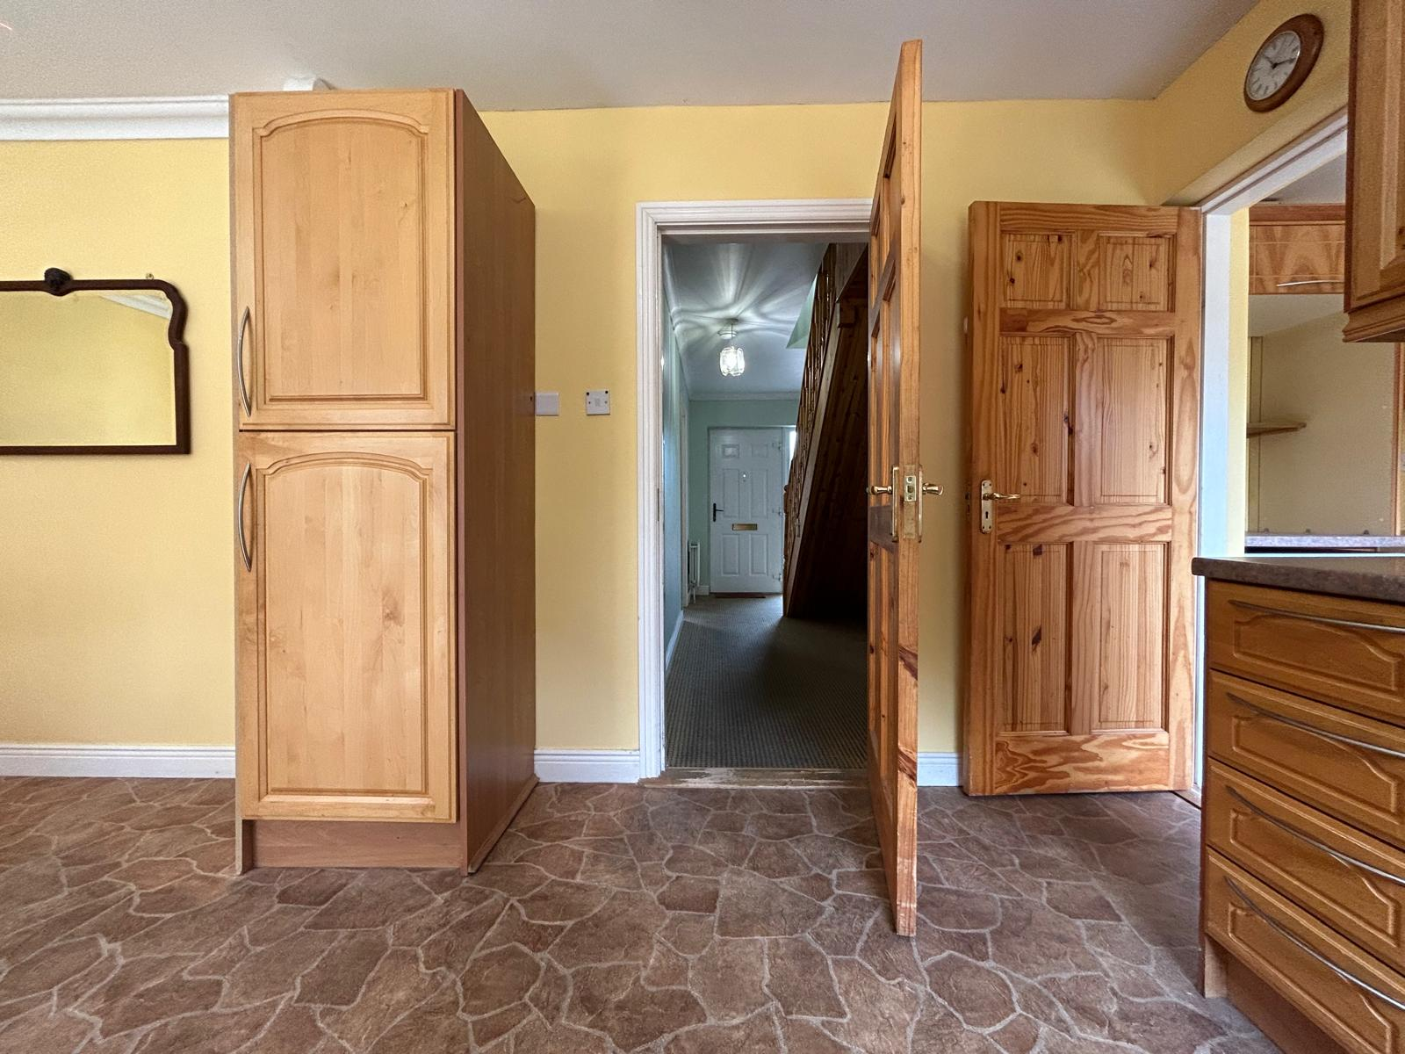
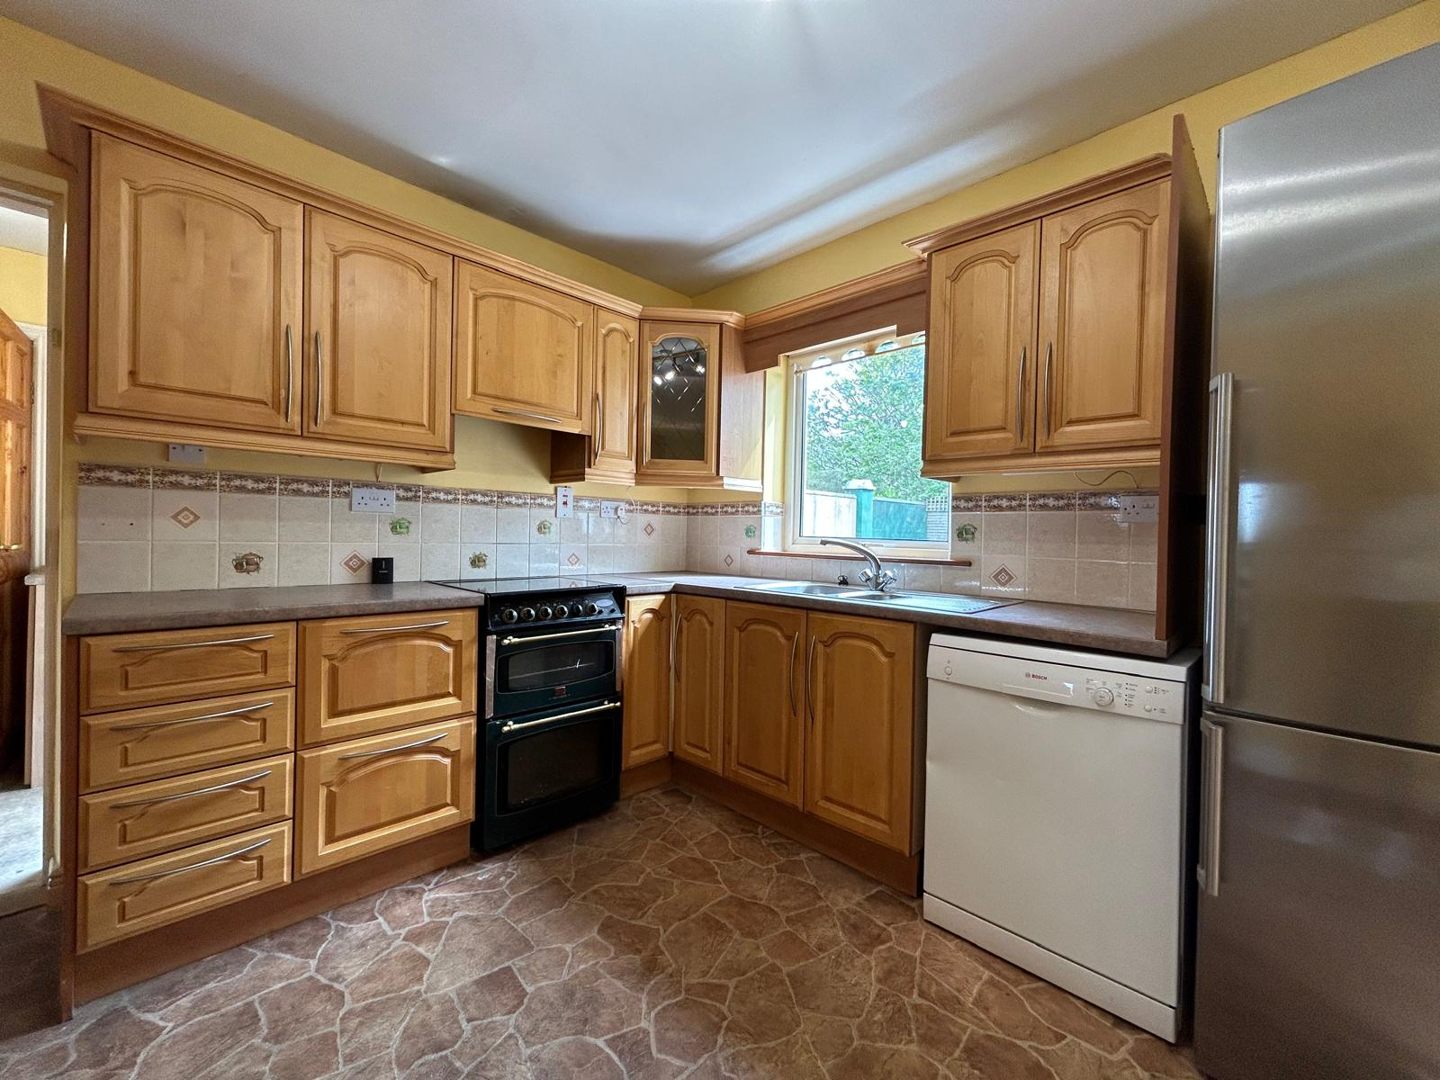

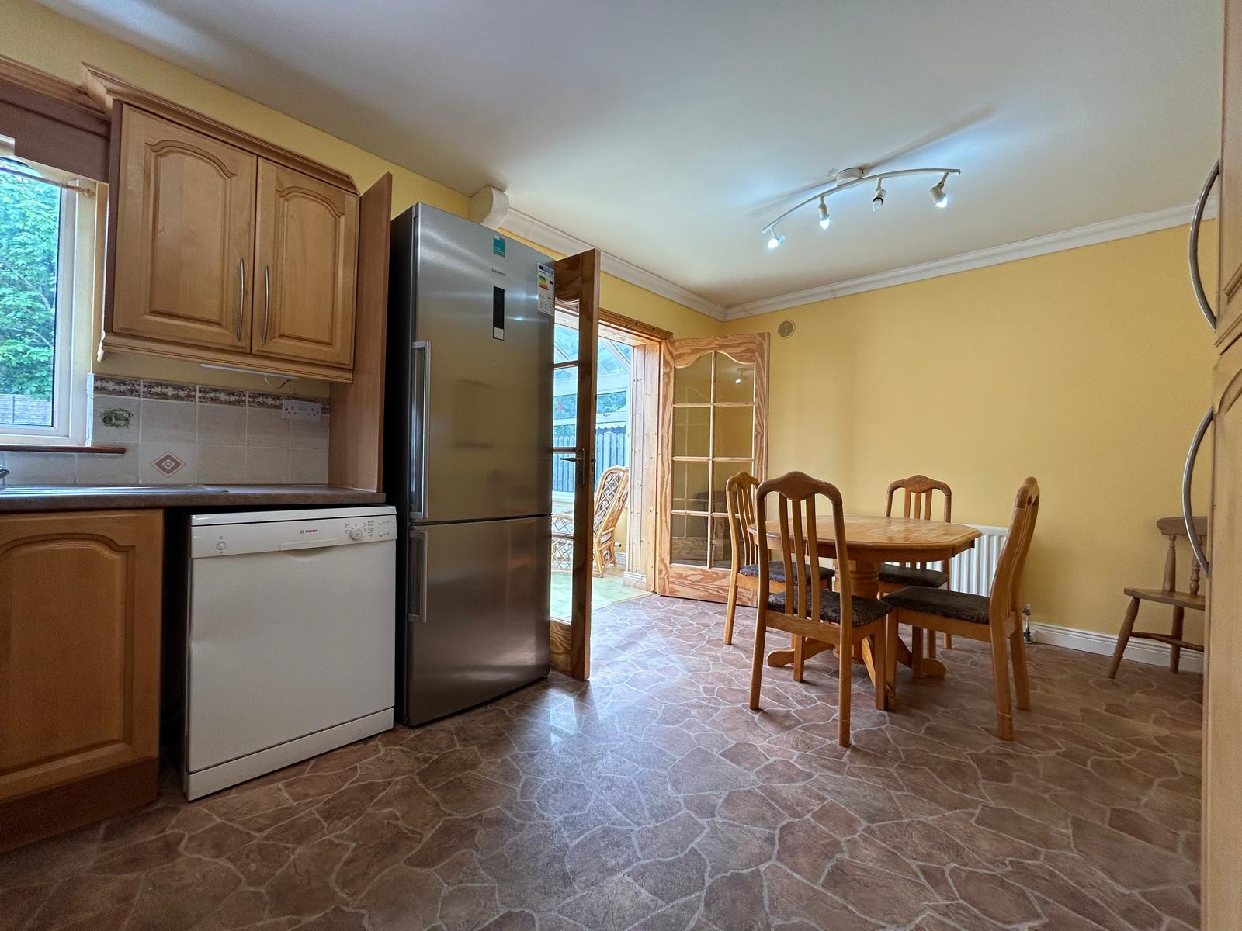

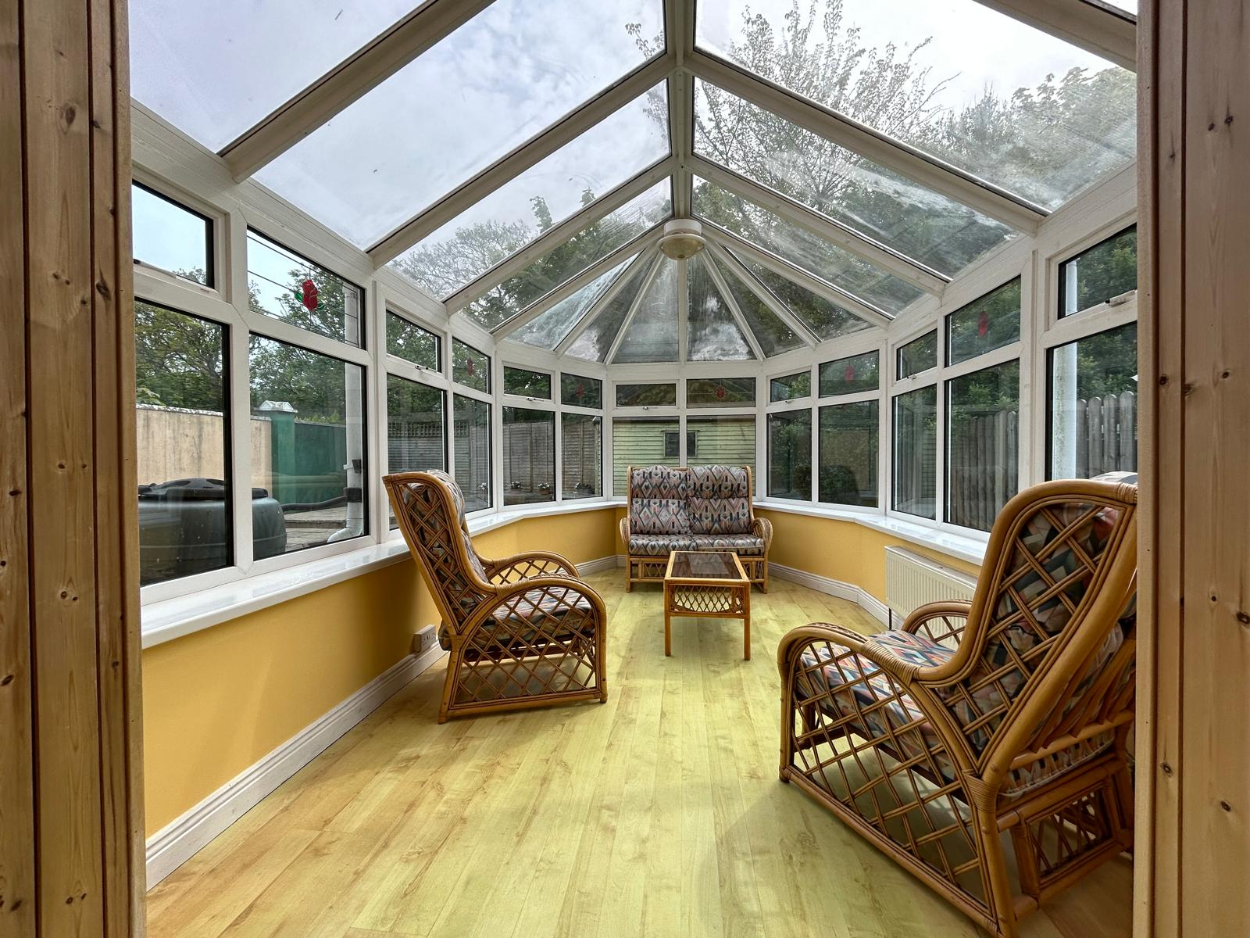

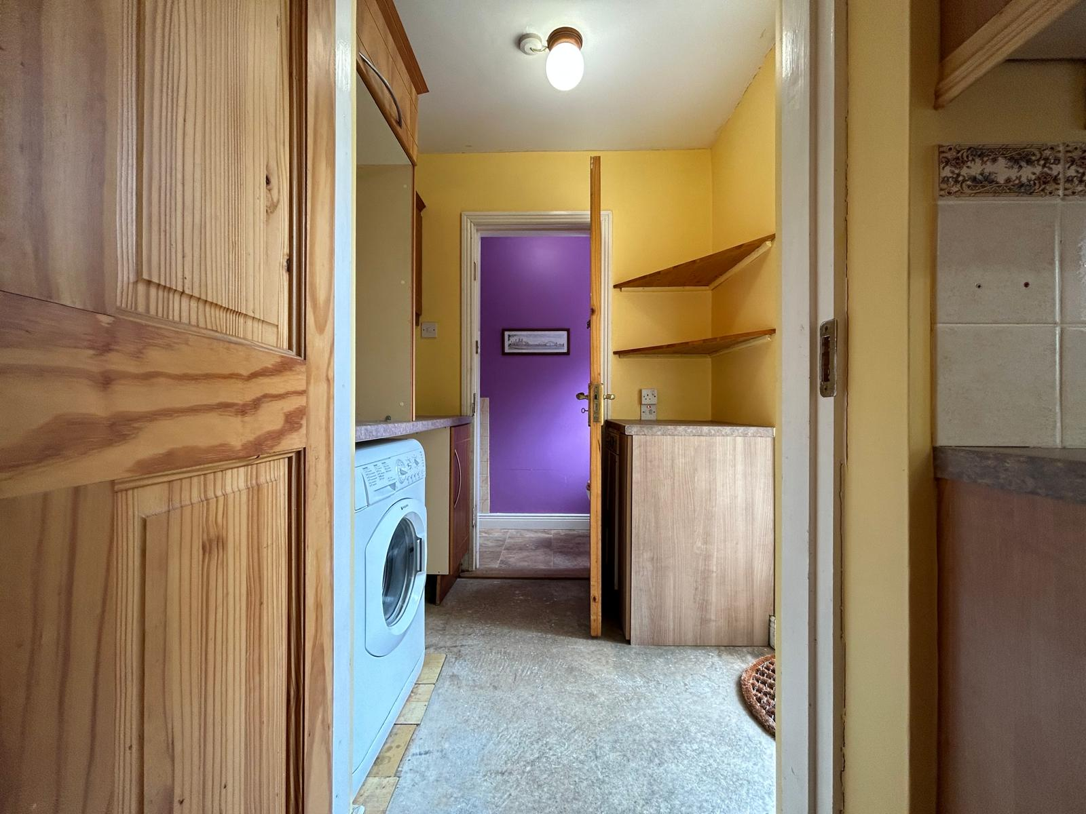

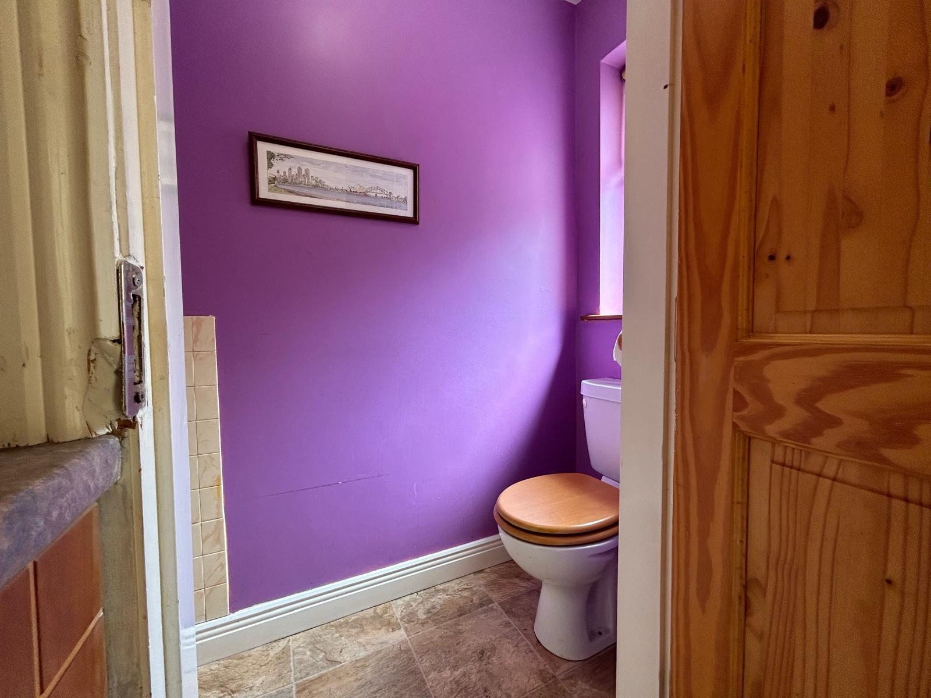

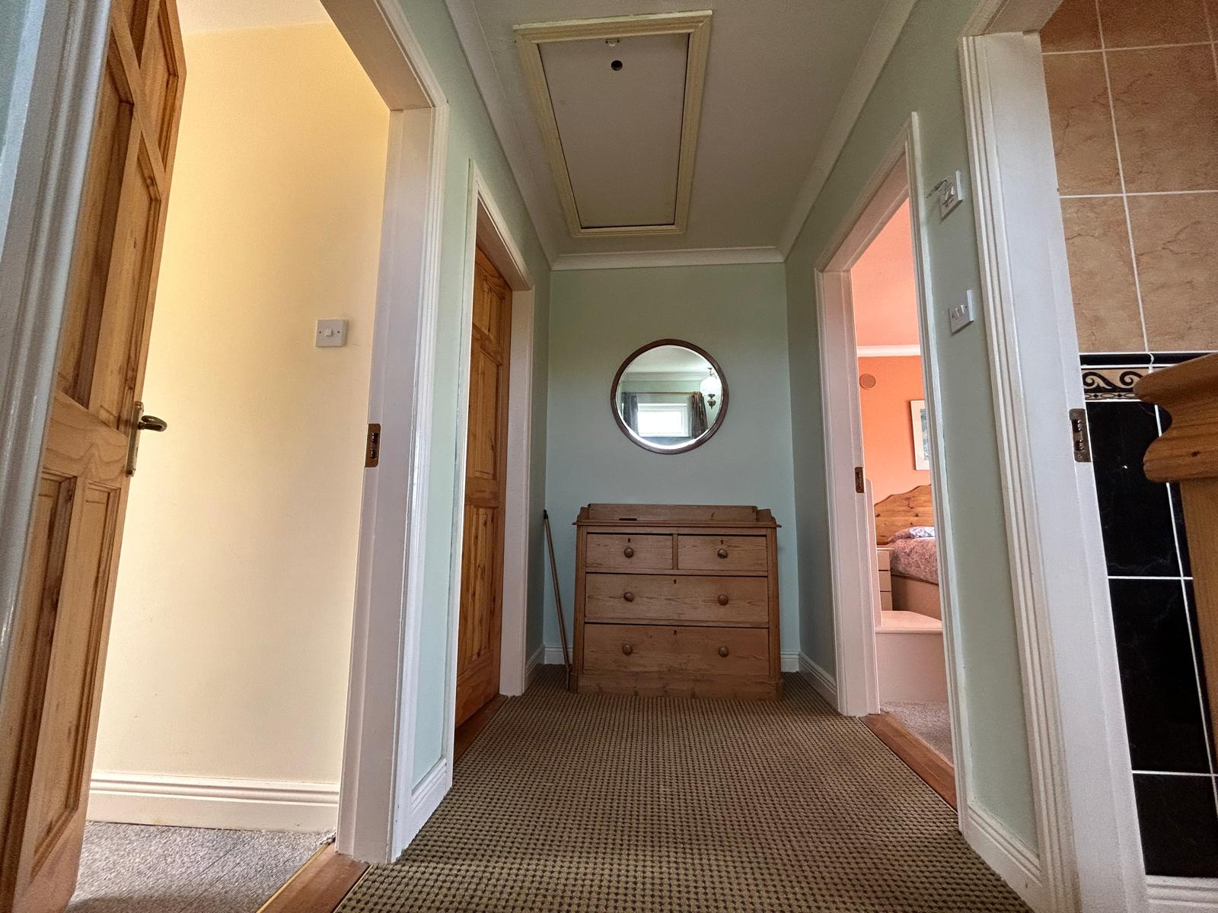
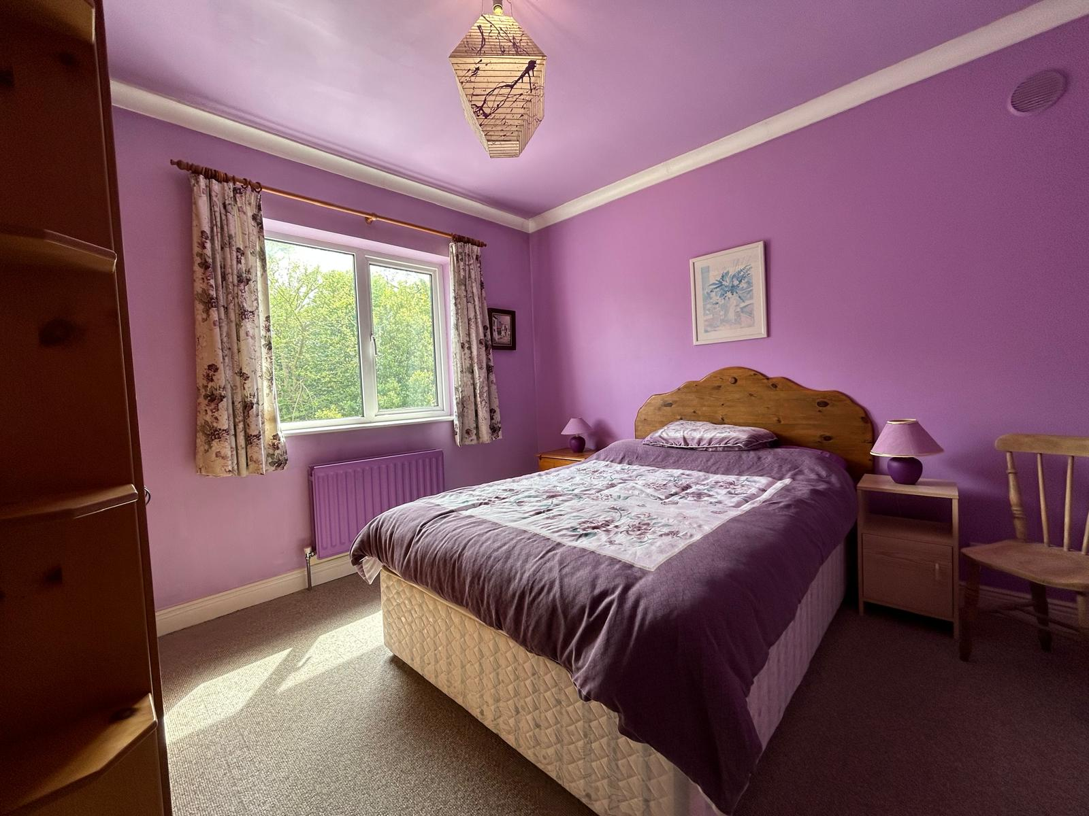

Total Floor Area: c. xxx sq.m. / xxxx sq.ft.

1st Floor

Landing Area | 2.75m x 1.48m | Carpeted flooring Stira staircase to attic,
Master Bedroom | 3.42m x 3.50m | Carpet flooring, built in wardrobe with open shelves drawers, feature bay window overlooking font driveway. Coving, ceiling rows.
Ensuite | 1.65m x 1.47m | Tile flooring floor to ceiling tile surround, enclosed corner shower, triton t90z electric shower w.h.b., mirror and lighting overhead and w.c.
Bedroom 2 | 3.26m x 3.26m | Carpet flooring, coving, built in wardrobes, large window overlooking rear garden
Bedroom 3 | 3.27m x 2.18m | Carpeted flooring, window overlooking rear garden.
Family Bathroom | 3.15m (max ) x 2.01m | Tile flooring, floor to ceiling tile surround, bath with triton aqua sensation shower wall mounted over the bath. w.h.b., mirror and lighting overhead. w.c.
Hot Press |  | Insulated cylinder hot press and ample storage.
Total Floor Area: c 124 sq.m. (c1335 sq.ft.)

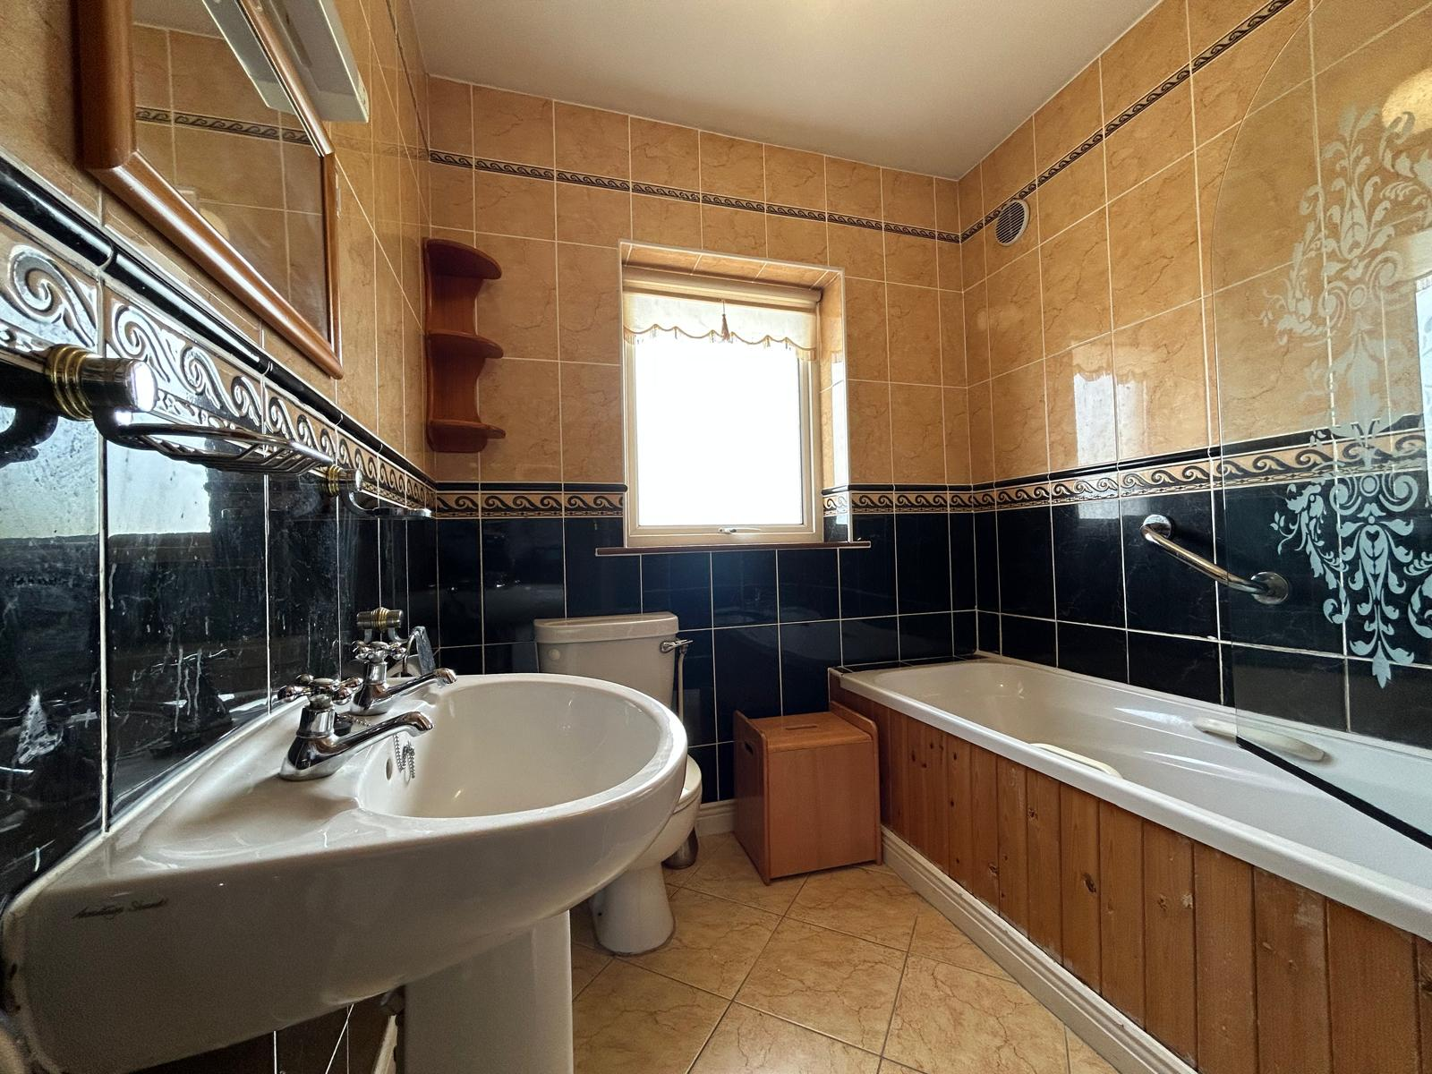
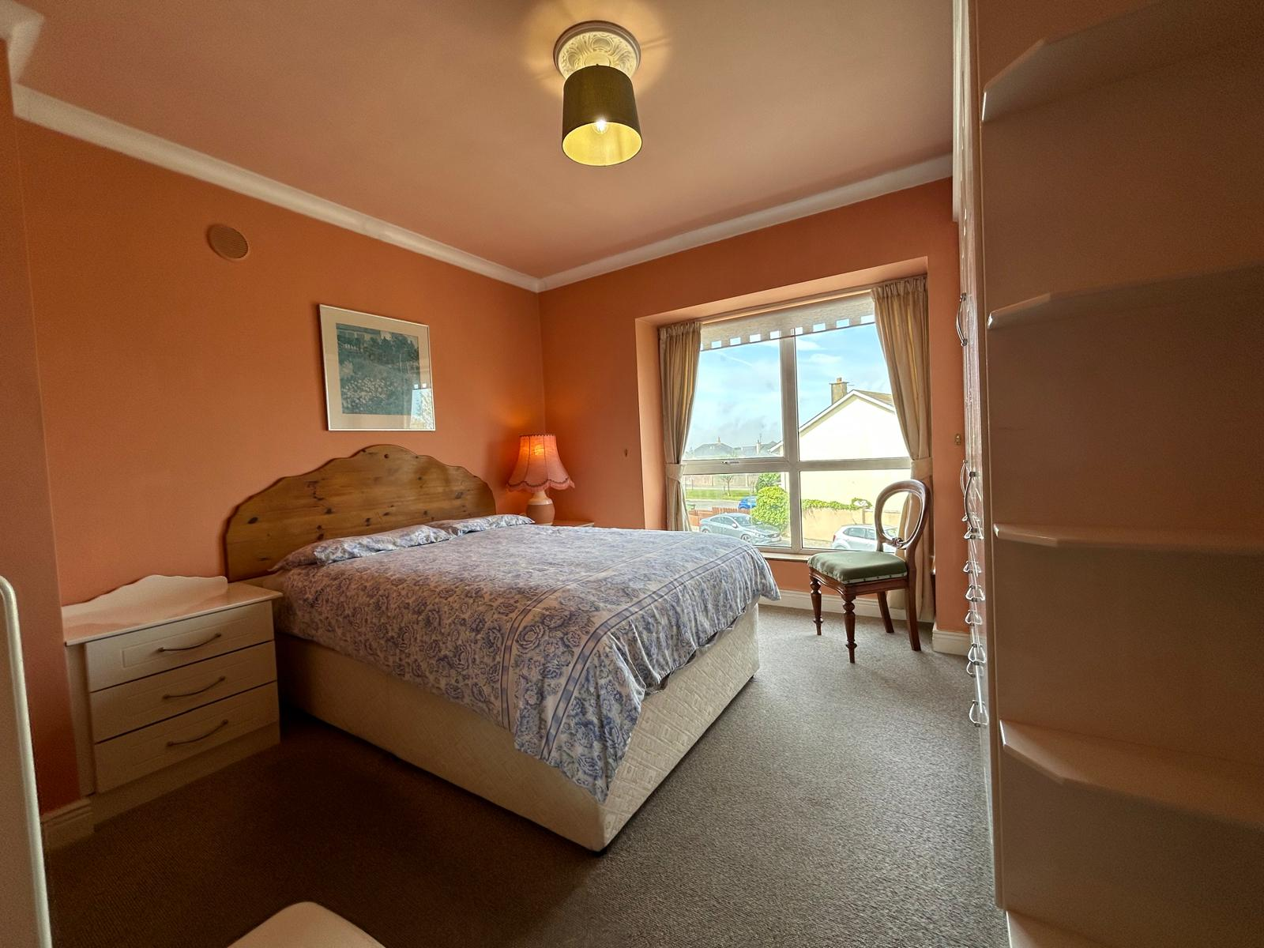

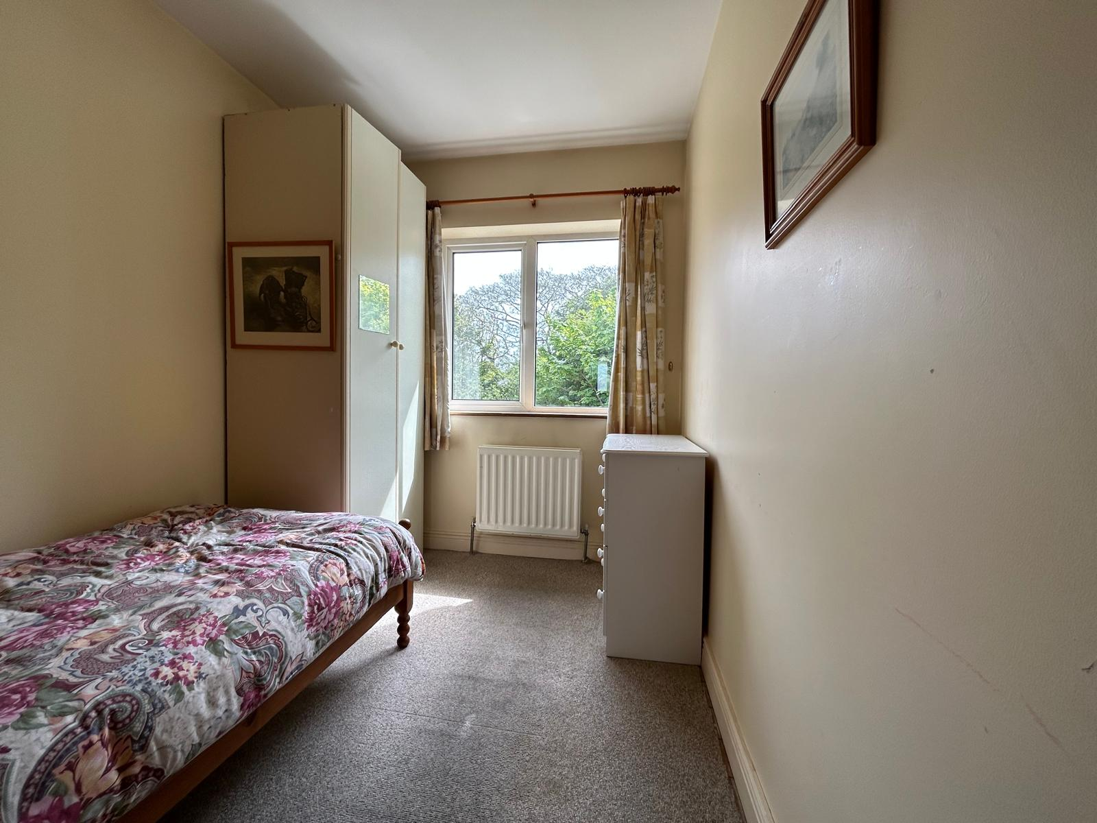
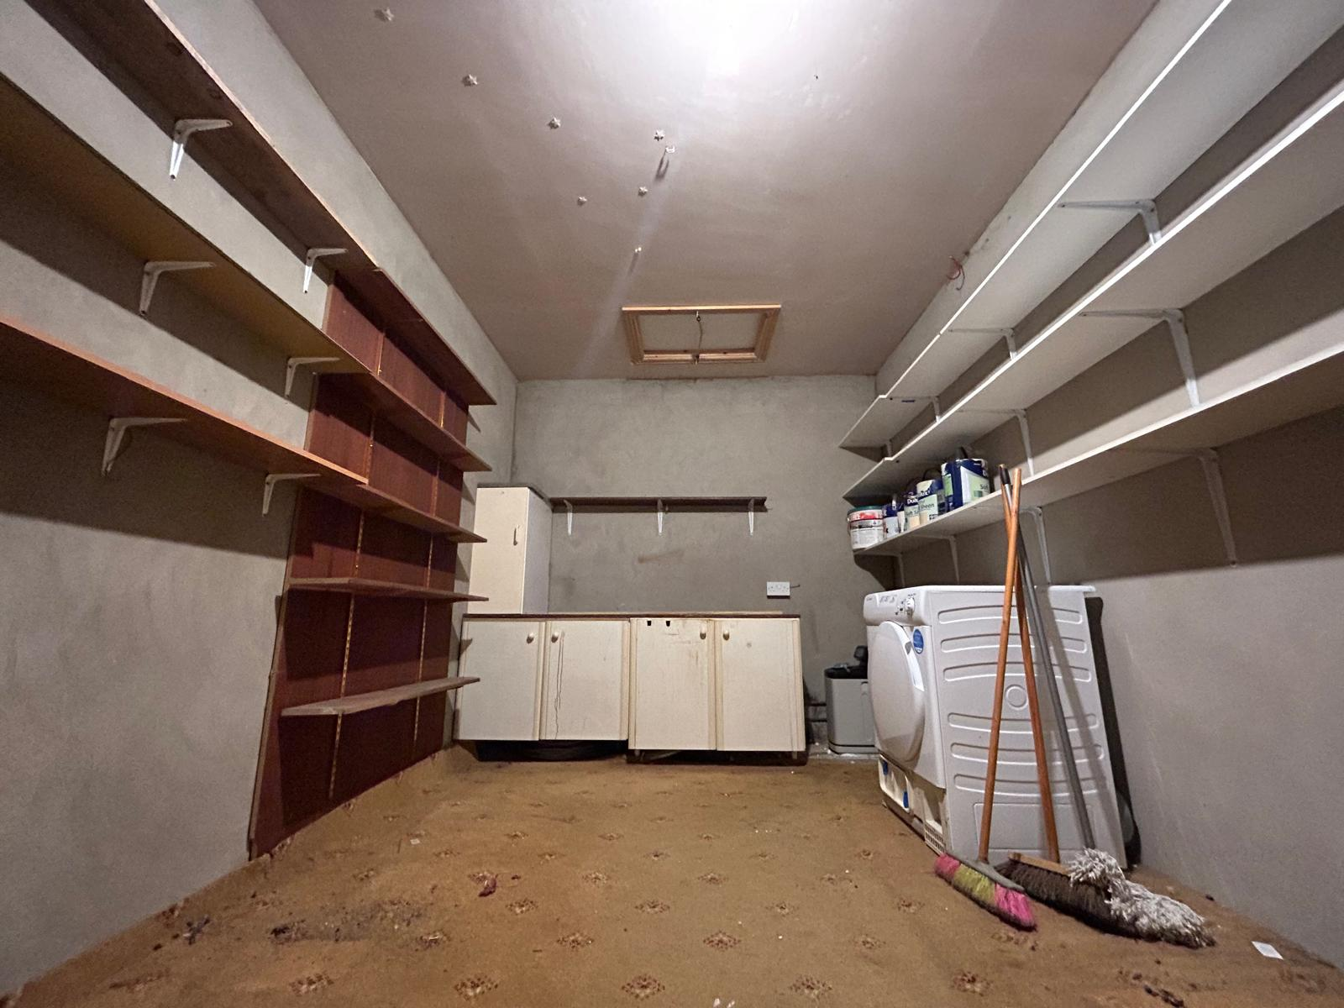

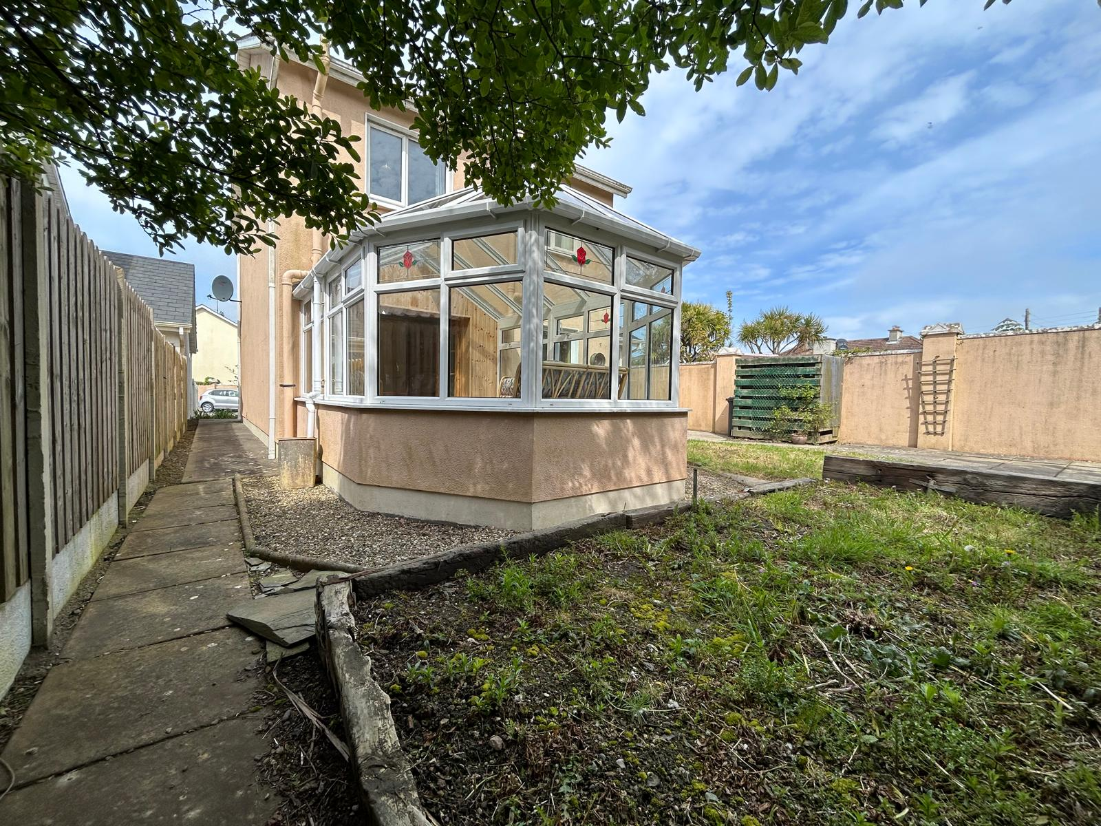

Outside  - Enclosed private rear garden  - Al fresco dining area  - Ample car parking space  - Low maintenance garden  - Garden shed | Services  - Mains water  - Mains drainage  - OFCH  - Water softener  - Broadband
Features  - Walking distance to shops & amenities  - Three bedrooms, three bathrooms  - Extending to c. 124 sq.m  - Built in 2000 | Building Energy Rating (BER): D2  BER No.: 117305805  Energy Performance Indicator: 290.83 kWh/m²/yr
VIEWING: Viewing is strictly by prior appointment and to arrange a suitable viewing time contact the sole selling agents, Kehoe & Assoc. at 053 9144393.

DIRECTIONS: Eircode Y35 KR77

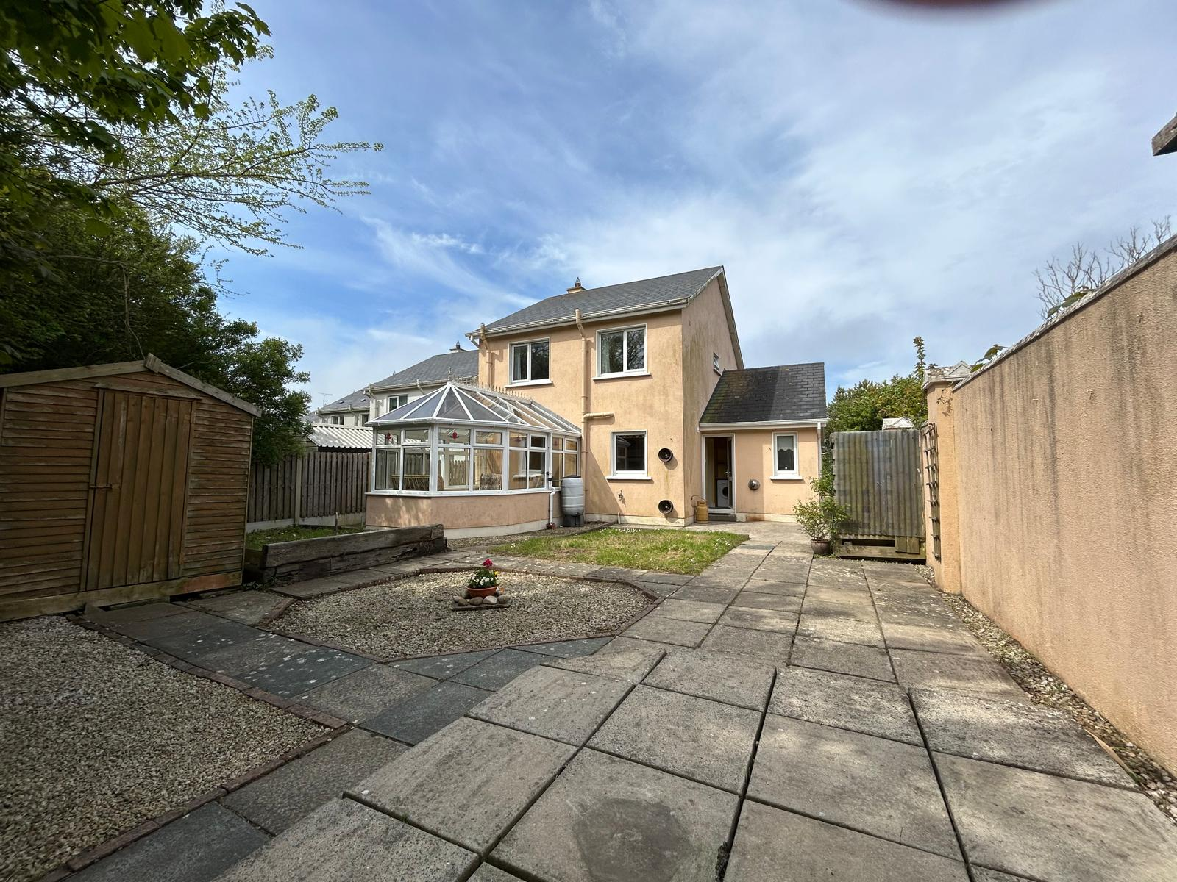

Building Energy Rating (BER): D2 BER No.: 117305805
Energy Performance Indicator: 290.83 kWh/m²/yr

VIEWING: Strictly by prior appointment with the sole selling agents only.
Contact Kehoe & Assoc. at 053 9144393 to arrange an appointment.

Sales Agent
CATRIONA MURPHY
087 2427525
Email: catriona@kehoeproperty.com

Kehoe & Assoc.,
Commercial Quay,
Wexford
053 9144393
www.kehoeproperty.com
Email: sales@kehoeproperty.com



These particulars are issued for guidance purposes only and do not form part of any contract
and are issued on the understanding that all negotiations regarding this property will be
conducted through this firm. PRSA No. 002141




